EXPERIMENT: 5 PARITY GENERATOR AND CHECKER
AIM: 1. To design and verify the truth table of a three bit odd parity generator and checker.
2. To design nine bit parity checker using IC 74180.

LEARNING OBJECTIVE:
- Realize parity generator and checker using logic gates.
- Study working of IC 74180

COMPONENTS REQUIRED:
IC Trainer kit, ICS 7400, IC 7486
THEORY:
PART 1:
A parity bit is used for the purpose of detecting errors during transmission of binary information. A parity bit is an extra bit included with a binary message to make the number of 1’s either odd or even. The message including the parity bit is transmitted and then checked at the receiving end for errors. An error is detected if the checked parity does not correspond with the one transmitted. The circuit that generates the parity bit in the transmitter is called a parity generator and the circuit that checks the parity in the receiver is called a parity checker. In even parity the added parity bit will make the total number of 1’s an even amount and in odd parity the added parity bit will make the total number of 1’s an odd amount. In a three bit odd parity generator the three bits in the message together with the parity bit are transmitted to their destination, where they are applied to the parity checker circuit. The parity checker circuit checks for possible errors in the transmission. Since the information was transmitted with odd parity the four bits received must have an odd number of 1’s. An error occurs during the transmission if the four bits received have an even number of 1’s, indicating that one bit has changed during transmission. The output of the parity checker is denoted by PEC (parity error check) and it will be equal to 1 if an error occurs, i.e., if the four bits received has an even number of 1’s.
ODD PARITY GENERATOR
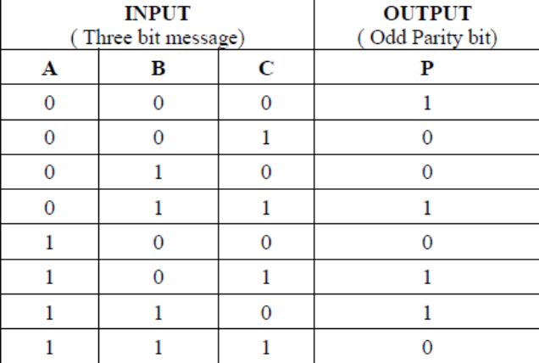
From the truth table the expression for the output parity bit is,
P (A, B, C) = Σ m (0, 3, 5, 6) Also written
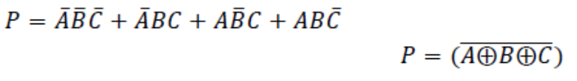
CIRCUIT DIAGRAM: ODD PARITY GENERATOR
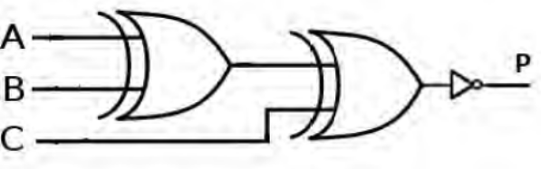

ODD PARITY CHECKER:
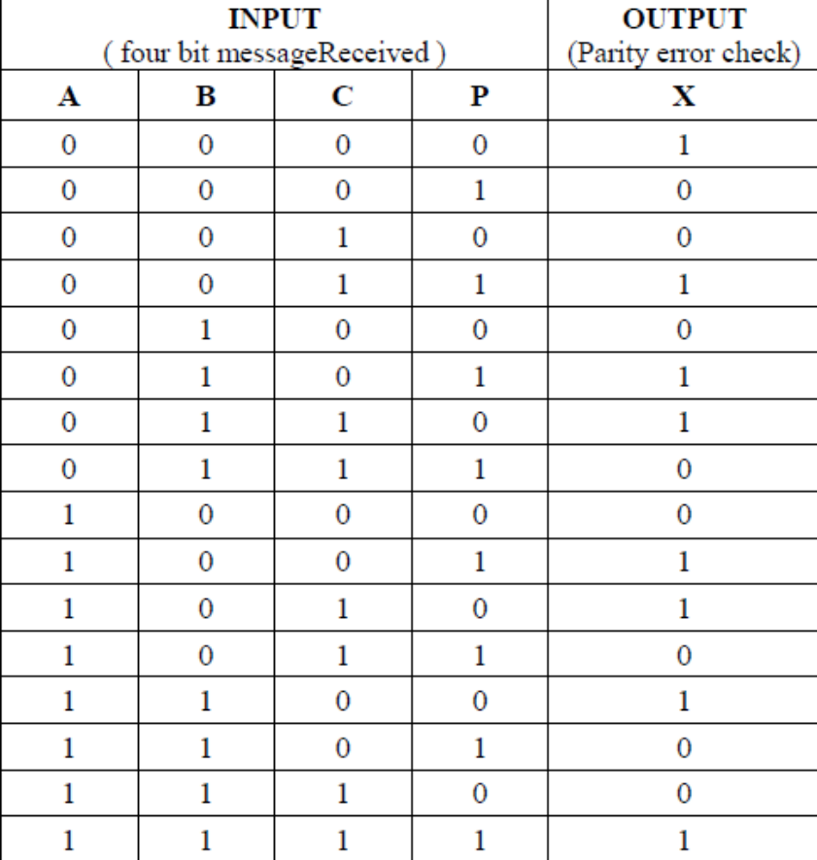

From the truth table the expression for the output parity checker bit is,
X (A, B, C, P) = Σ (0, 3, 5, 6, 9, 10, 12, 15)
The above expression is reduced as,
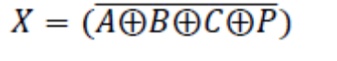

CIRCUIT DIAGRAM: ODD PARITY CHECKER
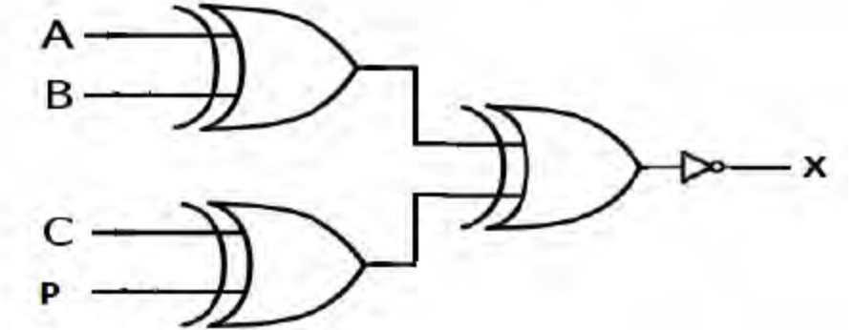

PROCEDURE:
- Connections are given as per the circuit diagrams.
- For all the ICs 7th pin is grounded and 14th pin is given +5 V supply.
- Apply the inputs and verify the truth table for the Parity generator and checker.

RESULT:
The design of the three bit odd Parity generator and checker circuits was done and their truth tables were verified.
PART 2:
There are different types of parity generator /checker ICs are available with different input configurations such as 5-bit, 4-bit, 9-bit, 12-bit, etc. A most commonly used and standard type of parity generator/checker IC is 74180.It is a 9-bit parity generator or checker used to detect errors in high speed data transmission or data retrieval systems. The figure below shows the pin diagram of 74180 IC.

PIN DIAGRAM FOR IC 74180(PARITY GENERATOR/ CHECKER):
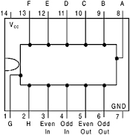

FUNCTION TABLE OF IC 74180 AS A PARITY CHECKER:
 | Cascading inputs |  | Outputs
Parity of Inputs  A through H | EVEN | ODD | 𝜮EVEN | 𝜮ODD
EVEN | 1 | 0 | 1 | 0
ODD | 1 | 0 | 0 | 1
EVEN | 0 | 1 | 0 | 1
ODD | 0 | 1 | 1 | 0
X | 1 | 1 | 0 | 0
X | 0 | 0 | 1 | 1

Design of 9 –bit odd parity checker using IC 74180:
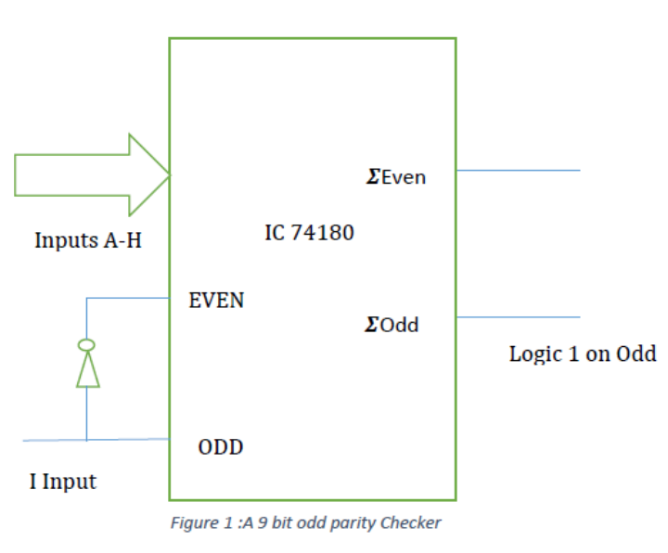
OBSERVATION TABLE
Parity through A –I  (Write binary input) | 𝜮Even | 𝜮Odd

Result and conclusion:
1 Designed and verified the truth table of a three bit odd parity generator and checker.
2. Designed and implemented9- bit parity checker using IC 74180.

POST LAB QUESTIONS: (Parity Generator and Checker)
- Design a 16-bit even parity Checker using IC 74180.
- Find the number of redundant (parity) bits to be added to 8-bit data.
- Construct the hamming code for the following 8- bit words
- 10101010
- 11111110
- For some 8-bit data words, the following Hamming code words are received. Determine which code words are in error and correct the erroneous word. Assume even parity check.
- 000011101010
- 101110000110

